

Yarmouk University
Faculty: Information Technology and Computer Science
Department: Business information technology

Taste-Lens
Team Members

Hashem Alrabee | 2021903056 | 2021903056@ses.yu.edu.jo
Assem Abu Diak | 2021903036 | 2021903036@ses.yu.edu.jo
Heba Mahaftha | 2022903119 | 2022903119@ses.yu.edu.jo
Ekhlas AL-khaldy | 2020903006 | 2020903006@ses.yu.edu.jo

Under the supervision of : Dr. Ala-deen Hamoud

Declaration

Plagiarism is the breach of copyright or using another person’s work and pretending that is one's own.

WE, project team members recognize what plagiarism is and WE hereby declare that this project, which is submitted to National Technology Parade, is our own work. WE have not plagiarized from any sources (including copy and paste). All references and acknowledgments of sources are given and cited in our project. WE have used the conventional citation and referencing. Each significant contribution to and quotation in this project from work of other people has been attributed and referenced.
Ekhlas AL-khaldy

Group Member | Group Member | Group Member | Group Member
Name  Hashem Alrabee | Name  Assem Abu Diak | Name  Heba Mahaftha | Name  Ekhlas AL khaldy
Signature  ................................... | Signature  ................................... | Signature  ................................... | Signature  ...................................
Date  ................................... | Date  ................................... | Date  ................................... | Date  ...................................

Table of Contents
CHAPTER ONE: INTRODUCTION 4
CHAPTER TWO: ANALYSIS PHASE 5
CHAPTER THREE : DESIGN PHASE 6
CHAPTER FOUR : IMPLEMENTATION PHASE 7
CHAPTER FIVE : CONCLUSION 8
References 8
APPENDIX A: User Manual 8
APPENDIX B : Project SOURCE CODE 9

CHAPTER ONE: INTRODUCTION
Project Description and Objectives

Taste-Lens is an intelligent, AI-powered cross-platform application designed to help users discover food and entertainment experiences that match their personal mood, preferences, and geographical location. In today’s fast-paced lifestyle, many individuals struggle to decide where to eat or which activity to choose, especially when overwhelmed by numerous options. Taste-Lens addresses this problem by combining artificial intelligence with user-centered design to provide personalized and context-aware recommendations. The system analyzes user input, such as mood and interests, along with location data, to suggest suitable restaurants and leisure activities, offering a smarter and more efficient decision-making experience.

Taste-Lens aims to enhance the user experience by delivering smart, personalized recommendations that adapt over time based on user behavior and feedback. The main objective of the project is to utilize artificial intelligence techniques to analyze user moods, preferences, and location data in order to suggest the most suitable dining and entertainment options. By learning from previous interactions and user ratings, the system continuously improves the accuracy of its recommendations. Additionally, the project seeks to support local restaurants and entertainment venues by increasing their visibility and connecting them with potential customers who are genuinely interested in their offerings.

The importance of the Taste-Lens project lies in its ability to bridge the gap between user emotions and technology-driven decision making. Unlike traditional recommendation platforms that rely solely on ratings or popularity, Taste-Lens introduces mood-based and context-aware recommendations, making the user experience more human-centered and meaningful. The system can be used in various scenarios, such as helping individuals choose a suitable restaurant after a long day, assisting tourists in discovering local experiences, or supporting users who are unsure about what activity matches their current mood. By combining artificial intelligence, location-based services, and user feedback, Taste-Lens provides a practical and innovative solution that can be applied in real-life situations and expanded in future developments.

CHAPTER TWO: ANALYSIS PHASE
This chapter presents a detailed analysis of the Taste-Lens project, focusing on the problem domain, system objectives, and overall requirements. The analysis phase plays a critical role in defining what the system is expected to achieve and how it addresses real-world user needs. Taste-Lens is designed to solve the common problem faced by many individuals who struggle to choose suitable food or entertainment options due to the abundance of choices and lack of personalized guidance. With the rapid growth of digital platforms and online services, users are often overwhelmed by large amounts of information, making decision making more complex and time-consuming. Taste-Lens aims to reduce this complexity by providing intelligent, personalized recommendations that align with the user’s current situation.
One of the key challenges addressed by the project is the gap between traditional recommendation systems and human emotional needs. Most existing platforms rely heavily on general ratings, popularity, or generic filters, which may not accurately reflect a user’s current mood or preferences. Taste-Lens approaches this challenge by incorporating mood-based analysis and contextual information, such as location and user behavior, to deliver more meaningful and relevant suggestions. By analyzing user input and interaction history, the system can better understand individual preferences and provide recommendations that feel more personal and adaptive.
The primary objective of the Taste-Lens project is to develop an intelligent recommendation system that provides personalized and context-aware suggestions for food and entertainment experiences. The system targets a wide range of users, including young adults, tourists, and individuals who enjoy exploring new dining and leisure activities. These users often face difficulties in making quick decisions, especially when visiting new places or searching for experiences that match their emotional state. By leveraging artificial intelligence techniques, Taste-Lens analyzes user mood, preferences, and location data to ensure that the recommendations align closely with the user’s emotional and situational context.
Another important objective of the project is continuous improvement through user feedback. Taste-Lens allows users to rate and interact with the recommended options, enabling the system to learn from previous experiences. This feedback-driven approach helps refine the recommendation logic over time, increasing accuracy and user satisfaction. Unlike static systems, Taste-Lens evolves as more data is collected, making it more responsive to changing user behaviors and preferences. This adaptive nature enhances the overall effectiveness of the system and supports long-term usability.
From a functional perspective, the system provides essential features that support a complete user journey. Users can register and log in securely, create a personal profile, and input their current mood and preferences through simple and intuitive interfaces. Based on this information, the system generates personalized recommendations that consider both user preferences and geographical location. Users can view detailed information about recommended restaurants or activities, including descriptions and locations, and provide feedback after their experience. These functionalities ensure that the system meets user expectations while maintaining ease of use.
In addition to functional requirements, non-functional requirements play a crucial role in the system’s success. Performance is a key consideration, as users expect fast response times when interacting with recommendation systems. Taste-Lens is designed to deliver results efficiently without noticeable delays. Usability is another important factor, as the system must be easy to navigate and visually appealing to encourage continued use. Scalability is also considered to ensure that the system can handle an increasing number of users and data as the platform grows. Furthermore, security and privacy are prioritized to protect sensitive user information and ensure secure authentication and data handling.
The importance of the Taste-Lens project extends beyond individual users. The system can also benefit local restaurants, cafés, and entertainment venues by increasing their visibility and connecting them with potential customers who are genuinely interested in their offerings. By matching users with suitable businesses based on preferences and mood, Taste-Lens creates value for both users and service providers. This makes the system applicable in real-world environments such as urban areas, tourist destinations, and digital lifestyle platforms.
Overall, the analysis phase establishes a comprehensive understanding of the system requirements, objectives, and constraints. It ensures that the proposed solution is aligned with user needs, technical feasibility, and business considerations. This phase forms a strong foundation for the subsequent design and implementation stages, where the system architecture, data models, and technical components are developed based on the analyzed requirements. By clearly defining the scope and goals of the project, the analysis phase contributes significantly to the success and effectiveness of the Taste-Lens system.

CHAPTER THREE : DESIGN PHASE

3.1 Design Overview

This chapter describes the design of the Taste-Lens system, focusing on how the different components interact to deliver personalized food and entertainment recommendations. The design phase translates the requirements identified in the analysis phase into a structured system architecture that ensures efficiency, scalability, and ease of use. Taste-Lens is designed as a modular system consisting of a user interface layer, an application logic layer, an artificial intelligence recommendation engine, and a centralized database.
At a high level, the system workflow begins when the user interacts with the mobile or web interface to log in and input their current mood and preferences. This information is processed by the backend logic, which communicates with the AI recommendation engine. The AI engine analyzes the user input alongside stored user data, location information, and historical feedback to generate suitable recommendations. The system then retrieves relevant restaurant or activity data from the database and presents the personalized results to the user in an intuitive format.
The system design follows a client-server architecture to ensure separation of concerns. The front-end handles user interaction and presentation, while the backend manages business logic, data processing, and communication with external services such as location-based APIs. This architectural approach improves maintainability and allows each component to be developed and scaled independently.

This section should include subsections on:
- Functional Requirement Specifications
- Business Functions and Structure (Dataflow diagrams)
- Scenarios and Use Case Specifications
- Conceptual Design (ER diagram)
- Logical Design (Relational Schema)
- Physical Structures (Tables, Fields, Indexes, etc.)

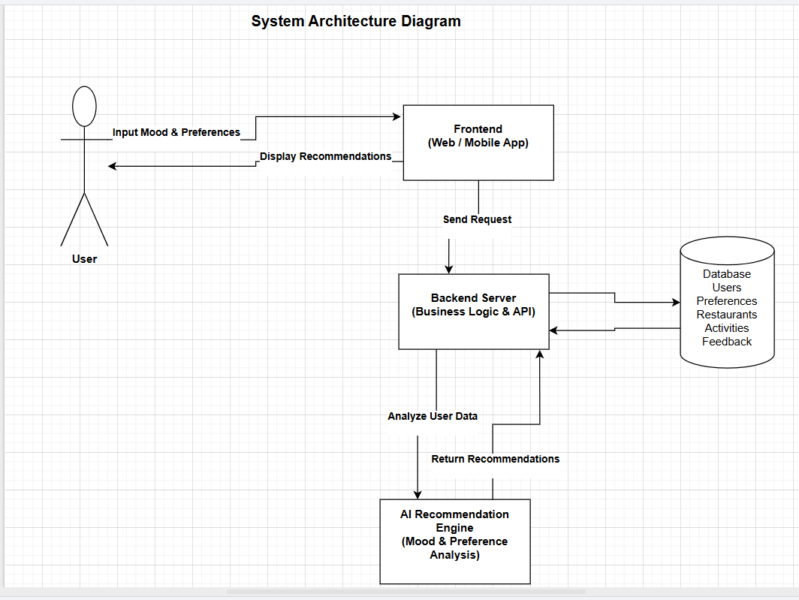

Figure 3.1: Taste-Lens System Architecture Diagram
This figure illustrates the overall system architecture of the Taste-Lens application. It demonstrates how the user interacts with the frontend application to input mood and preferences and receive personalized recommendations. The frontend sends requests to the backend server, which handles business logic and communicates with the AI recommendation engine to analyze user data. The backend also interacts with the database to retrieve and store user information, preferences, restaurants, activities, and feedback, enabling the system to generate accurate and personalized recommendations.

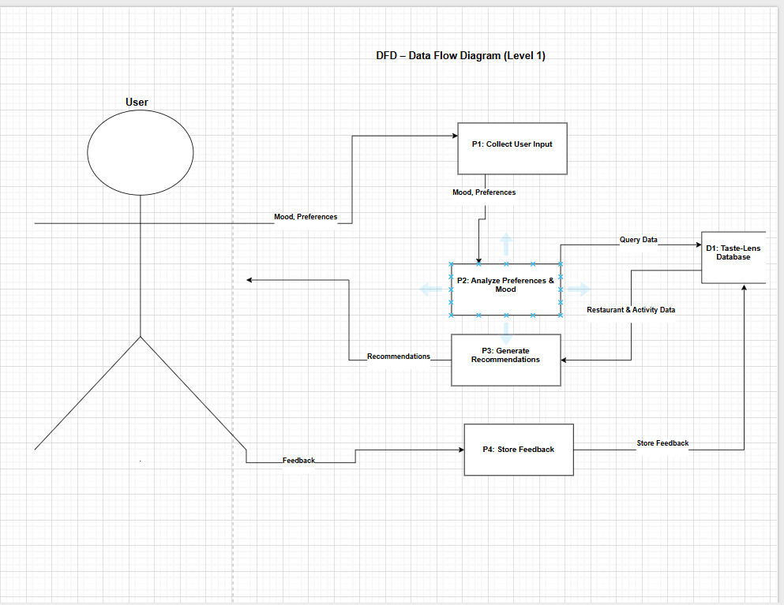
Figure 3.2: Data Flow Diagram (Level 1)
This figure illustrates the Level 1 Data Flow Diagram of the Taste-Lens system. It demonstrates how user mood and preferences are collected, analyzed, and used to generate personalized recommendations. The diagram also shows how restaurant and activity data are retrieved from the database and how user feedback is stored to continuously improve the recommendation process.

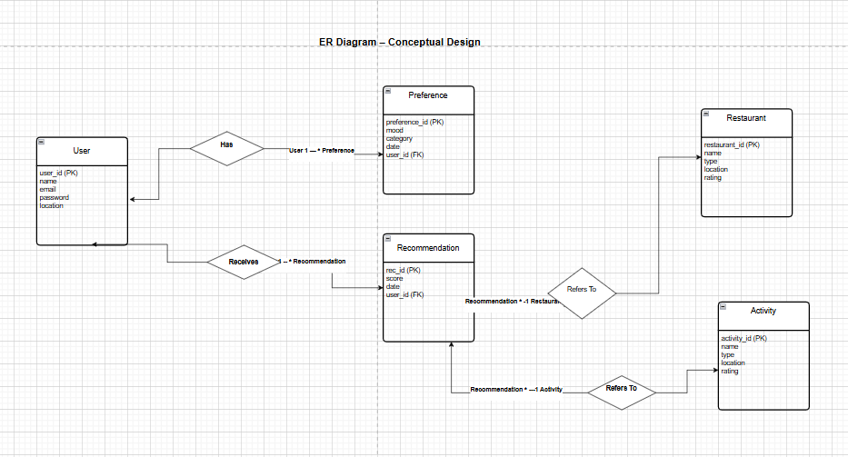

Physical Structures (Tables, Fields, Indexes)
The physical database structure of the Taste-Lens system is designed to ensure efficient data storage, fast retrieval, and data integrity. Tables are created based on the relational schema, with appropriate data types and indexing strategies.
- User Table:
Stores user profile data. The user-id field is indexed as a primary key. Email is indexed to support fast login operations.
- Restaurant and Activity Tables:
Store categorized venue data. Indexes are applied on location and type fields to improve recommendation query performance.
- Recommendation Table:
Acts as a transactional table linking users with recommended restaurants or activities. Indexes on user-id and date improve retrieval of recent recommendations.
Foreign key constraints are enforced to maintain referential integrity, and sensitive data such as passwords are stored using encryption techniques to enhance security.

CHAPTER FOUR : IMPLEMENTATION PHASE
This chapter presents the implementation details of the Taste-Lens project. It provides a precise description of the software tools, technologies, and infrastructure used to develop the system. In addition, it discusses the implementation decisions, design trade-offs, system complexity, and dependencies that influenced the development process. The chapter also highlights the user interface functionalities and the availability of the complete source code.

4.1 Tools and Technologies Used
The Taste-Lens system is implemented using a modern and scalable software stack that supports cross-platform development and efficient data processing.
- Frontend(Web-Application):
The web interface is developed using React.js, which provides a component-based architecture and ensures a responsive and interactive user experience. The frontend handles user authentication, mood and preference selection, recommendation display, and feedback submission.
- Backend(Server-Side):
The backend is implemented using Node.js, providing a robust environment for handling RESTful APIs, business logic, authentication, and communication with the database. The backend manages all system operations, including request processing and interaction with the recommendation logic.
- Database and ORM:
A relational database is used to store user data, preferences, restaurants, activities, recommendations, and feedback. Prisma ORM is utilized to manage database schemas, migrations, and data access in a structured and maintainable manner.
- AI and Recommendation Logic:
The system incorporates AI-based logic to analyze user moods, preferences, and historical feedback. This logic enables the generation of personalized and adaptive recommendations that improve over time.
- External Services:
Location-based services such as Google Maps API are integrated to enhance recommendation accuracy by considering the user’s geographical context.

4.2 Information Technology Infrastructure
Taste-Lens follows a client-server architecture. Users access the system through a web or mobile interface, which communicates with the backend server via HTTP requests. The backend server interacts with the database and recommendation logic to process data and generate personalized results. This infrastructure supports scalability, modularity, and potential cloud deployment.

4.3 Design and Implementation Trade-Offs
Several trade-offs were considered during implementation. Using React.js and Node.js accelerates development and improves maintainability but requires careful handling of asynchronous operations. Choosing a relational database ensures data consistency and integrity, although it may require optimization when handling large datasets compared to NoSQL solutions. These decisions were made to balance performance, reliability, and development efficiency.

4.4 Implementation Complexity
The implementation complexity of Taste-Lens is higher than traditional recommendation systems that rely solely on static filters or ratings. The integration of mood-based analysis, feedback-driven learning, and location-aware recommendations increases system complexity. However, this complexity is managed through a modular design that separates frontend, backend, database, and recommendation logic, making the system easier to maintain and extend.

4.5 Dependencies and Assumptions
The implementation assumes reliable internet connectivity for accessing the backend services and external APIs. The accuracy of recommendations depends on the quality of user input and feedback. The system also depends on the availability of third-party services such as mapping APIs. It is assumed that users will interact with the system regularly and provide feedback to enhance recommendation accuracy.

4.6 User Interface and Source Code
The Taste-Lens user interface supports all core functionalities of the system, including user registration and login, mood and preference selection, viewing personalized recommendations, and submitting feedback. The interface is designed to be intuitive and user-friendly, ensuring smooth navigation and interaction.
The complete source code of the Taste-Lens project is fully implemented and provided as part of the project submission. It includes:
- Backend server source code
- Frontend web application source code
- Database schema and migration files
- Configuration and supporting files
The source code is organized in separate modules and is referenced in Appendix B: Project Source Code. Including the full code within the report is optional; therefore, it is provided as attached files for clarity and maintainability.

CHAPTER FIVE : CONCLUSION

5.1 Conclusion and Future Work
This project presented the design and implementation of Taste-Lens, an intelligent AI-powered system that provides personalized food and entertainment recommendations based on user mood, preferences, and location. The main contribution of this work lies in integrating emotional context into the recommendation process, moving beyond traditional systems that rely solely on ratings or popularity. By combining user input, location-based services, and feedback-driven learning, Taste-Lens delivers adaptive and context-aware recommendations that enhance user decision making.
Another important contribution of the project is the development of a modular and scalable system architecture. The separation between the frontend, backend, database, and recommendation logic allows the system to be easily maintained, extended, and deployed on different platforms. The use of modern technologies and structured design practices ensures that the system can support future growth in users and data without significant redesign.
Future work can further enhance the Taste-Lens system by incorporating more advanced machine learning models, such as deep learning or natural language processing, to analyze user input in greater depth. Additional features such as social recommendations, user behavior prediction, and real-time sentiment analysis from social media platforms could also improve recommendation accuracy. Expanding the system to support more categories and integrating additional data sources would further increase its value and usability.

5.2 Limitations
Despite its strengths, the Taste-Lens system has several limitations. One limitation is its reliance on explicit user input, such as mood and preferences. If users provide incomplete or inaccurate information, the quality of recommendations may be affected. This limitation could be addressed in the future by incorporating implicit behavior analysis, such as browsing history or interaction patterns, to better infer user preferences.
Another limitation relates to the availability and quality of data for restaurants and activities. The system’s effectiveness depends on having up-to-date and accurate information. In cases where data is limited or outdated, recommendations may not fully meet user expectations. This issue could be mitigated by integrating external data providers or allowing businesses to manage and update their own profiles within the platform.
Finally, the system currently depends on external services such as location-based APIs. Any downtime or changes in these services may impact system functionality. Future improvements could include fallback mechanisms or alternative service providers to enhance system reliability and reduce dependency on third-party platforms.

5.3 Economic Impact and Market Feasibility
The Taste-Lens project addresses a real and growing market need. Many users struggle to decide where to eat or which activity to choose, especially in urban environments with numerous options. By offering personalized, mood-based recommendations, Taste-Lens provides a practical solution that saves time and improves user satisfaction. This indicates strong market demand for such a product.
Deploying Taste-Lens in the Jordanian market is both feasible and promising. Jordan has a young, tech-savvy population and a rapidly growing digital ecosystem. The widespread use of smartphones and internet services supports the adoption of mobile and web-based applications. Additionally, local restaurants and entertainment venues can benefit from increased visibility and targeted customer engagement through the platform.
The primary customers of Taste-Lens include young adults, tourists, and individuals who frequently explore food and entertainment options. Local businesses such as restaurants, cafés, and activity providers also represent an important customer segment, as they can use the platform as a marketing and customer acquisition tool. Overall, Taste-Lens has the potential to create economic value by connecting users with businesses more effectively while supporting digital transformation in the local market.

References
[1] Google Maps Platform Documentation. Google Developers. Available at: https://developers.google.com/maps
[2] React Official Documentation. Meta Platforms, Inc. Available at: https://react.dev
[3] Node.js Documentation. Open-JS Foundation. Available at: https://nodejs.org/en/docs
[4] Prisma ORM Documentation. Prisma Labs. Available at: https://www.prisma.io/docs
[5] Ricci, F., Rokach, L., & Shapira, B. (2015). Recommender Systems Handbook. Springer.
[6] Aggarwal, C. C. (2016). Recommender Systems: The Textbook. Springer.
[7] Flutter Documentation. Google Developers. Available at: https://docs.flutter.dev
[8] React Native Documentation. Meta Platforms, Inc. Available at: https://reactnative.dev/docs
[9] Sommerville, I. (2016). Software Engineering (10th ed.). Pearson Education.
[10] Pressman, R. S., & Maxim, B. R. (2020). Software Engineering: A Practitioner’s Approach (9th ed.). McGraw-Hill.

APPENDIX A: User Manual
This user manual provides a step-by-step guide on how to use the Taste-Lens application. It explains the main functionalities of the system and how users can interact with the platform to receive personalized food and entertainment recommendations.

1. Accessing the Application
Users can access the Taste-Lens application through a web browser or a supported mobile platform. Upon opening the application, users are presented with the landing page, which introduces the system and its main features.
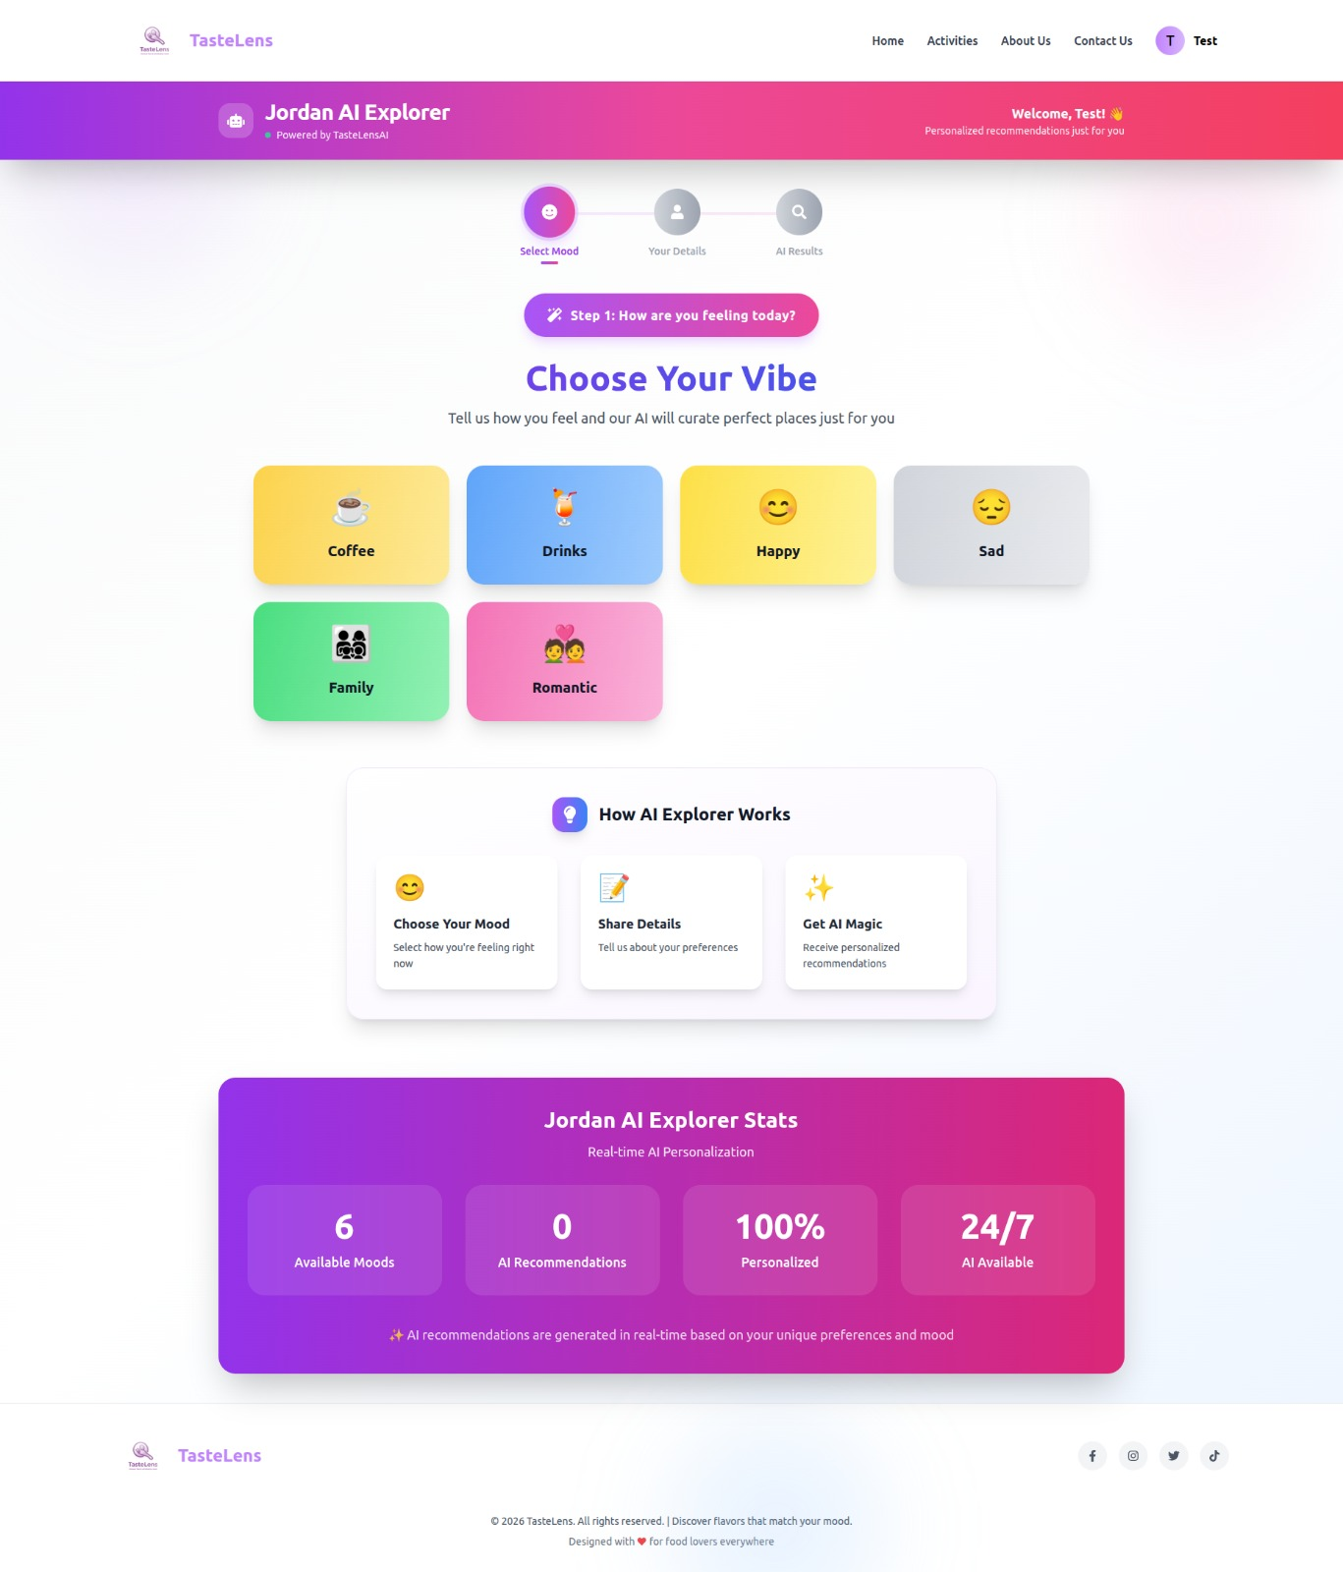
Figure A.1: Taste-Lens Landing Page

2. User Registration and Login
To use the full functionality of Taste-Lens, users must create an account or log in:
- Click on the Register button.
- Enter the required information such as name, email, and password.
- Submit the form to create a new account.
- Existing users can log in using their email and password.
Once authenticated, users are redirected to the main dashboard.
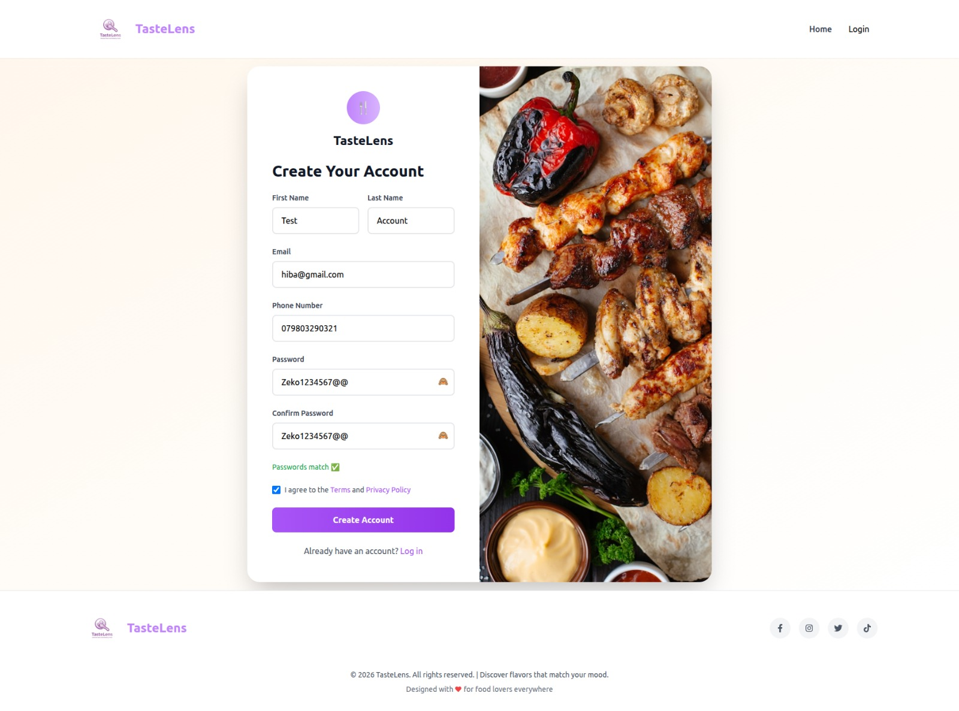
Figure A.2: User Registration Screen

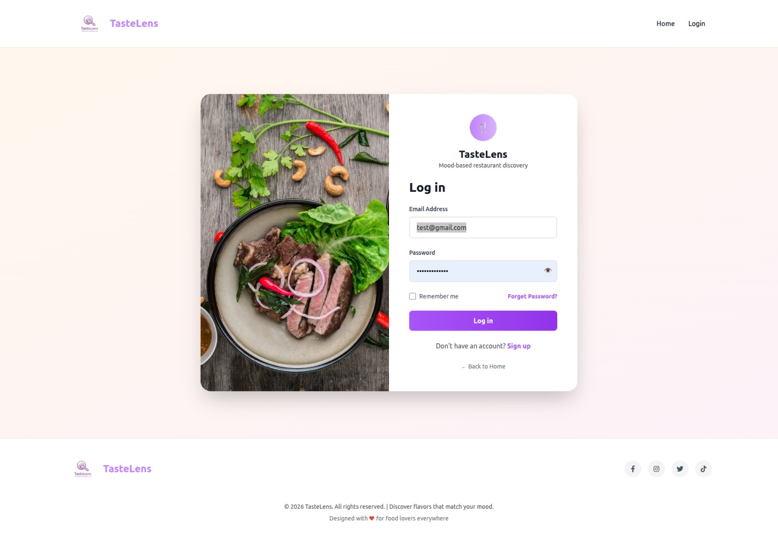
Figure A.3: User Login Screen

3. Mood and Preference Selection
After logging in, users can input their personal context and preferences through a structured selection process:
- Select the current mood from the available options (e.g., relaxed, energetic, happy).
- Choose the age range to help tailor recommendations appropriately.
- Specify the preferred budget or cost level (e.g., low, medium, high).
- Select the social status or context, such as solo, with friends, or family.
- Confirm the selected options to proceed.
The system uses this information to analyze the user’s context and generate personalized food and entertainment recommendations that best match the selected mood, budget, age group, and social

Figure A.4: Mood Selection Screen
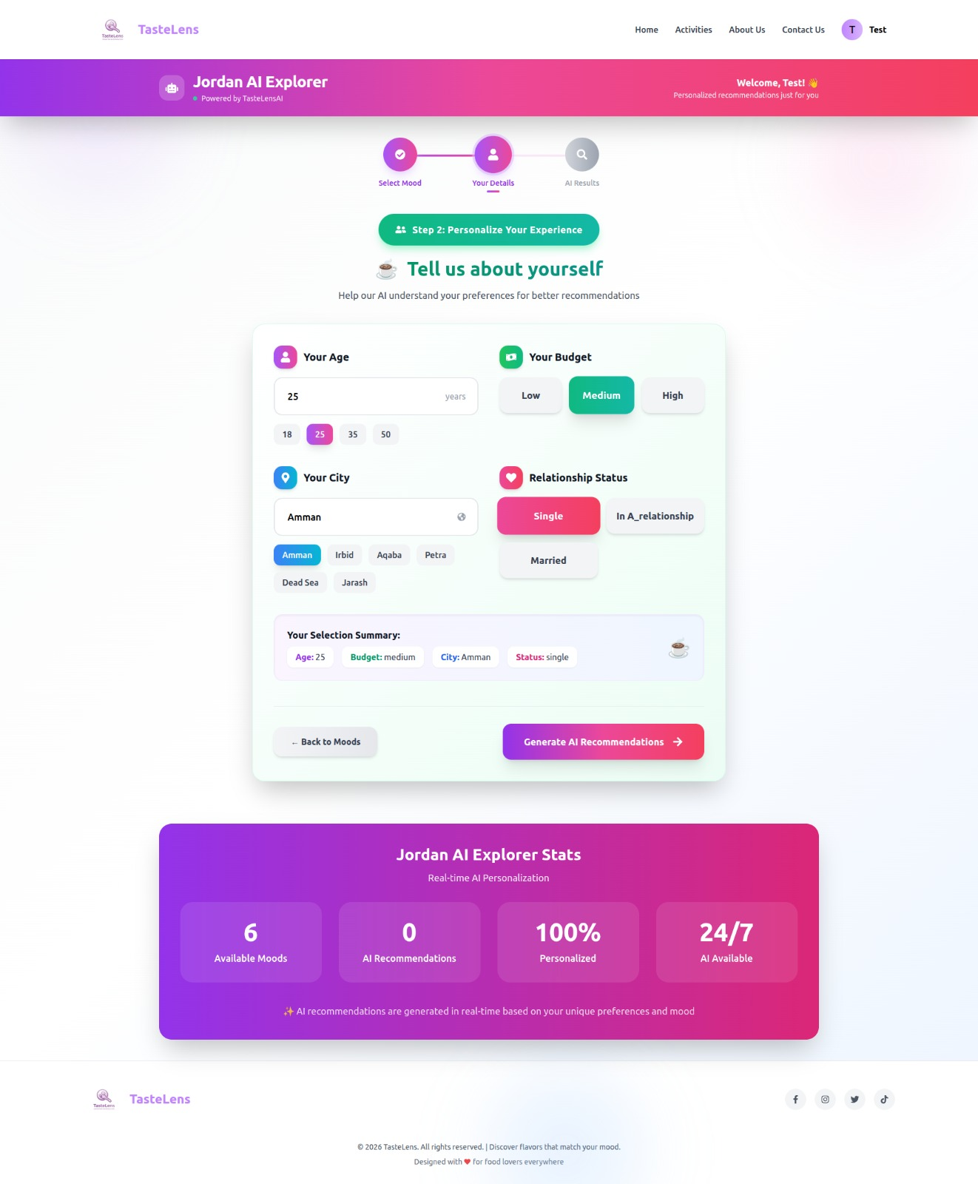
Figure A.5: User Details and Preference Selection Screen

4. Viewing Personalized Recommendations
Based on the selected mood, preferences, and user location, the system displays a list of recommended restaurants or activities:
- Recommendations are shown with basic details such as name, type, and rating.
- Users can click on any recommendation to view more details, including location and description.
- Location information may be displayed using an integrated map.

Figure A.6: Personalized Recommendations List Screen

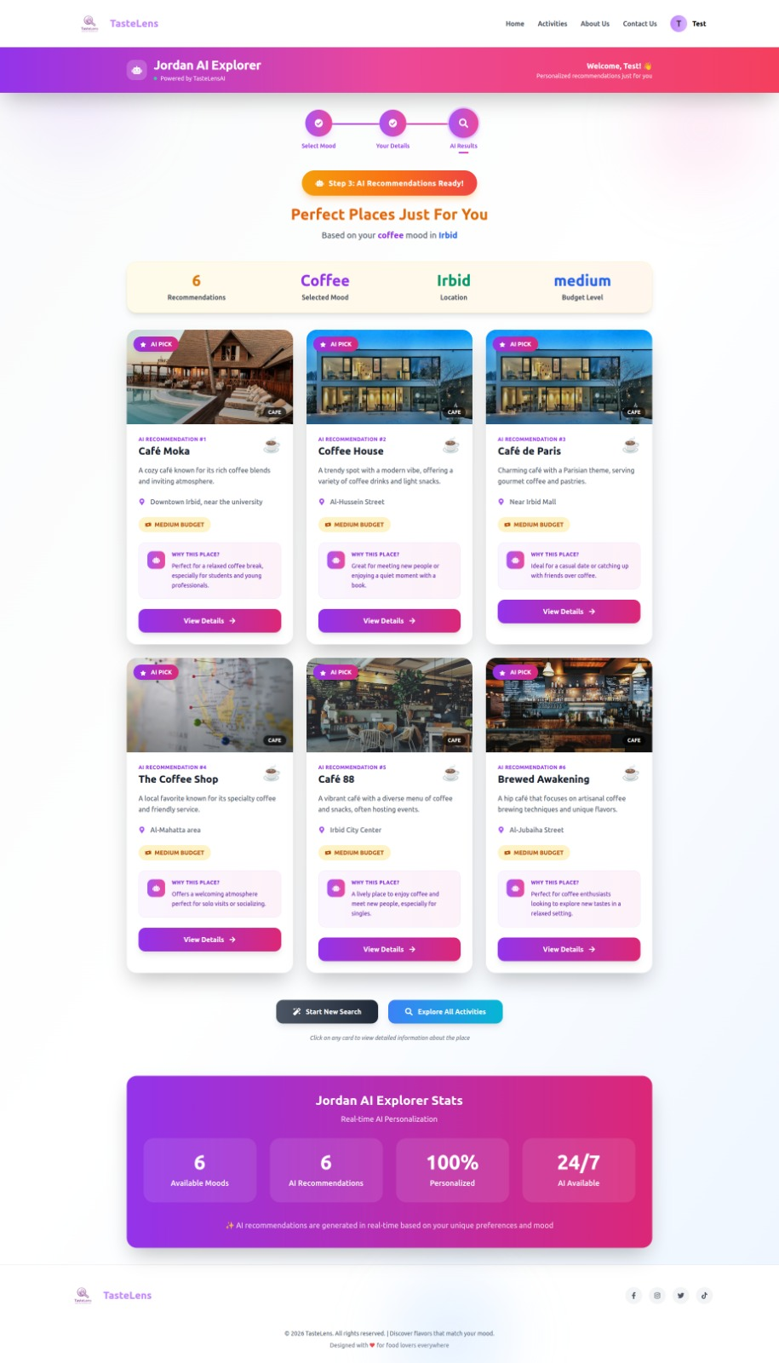

5. Providing Feedback
User feedback plays an important role in improving recommendation accuracy:
- After visiting a recommended place or activity, users can rate their experience.
- The feedback is submitted through the application.
- The system stores this feedback and uses it to improve future recommendations.
- 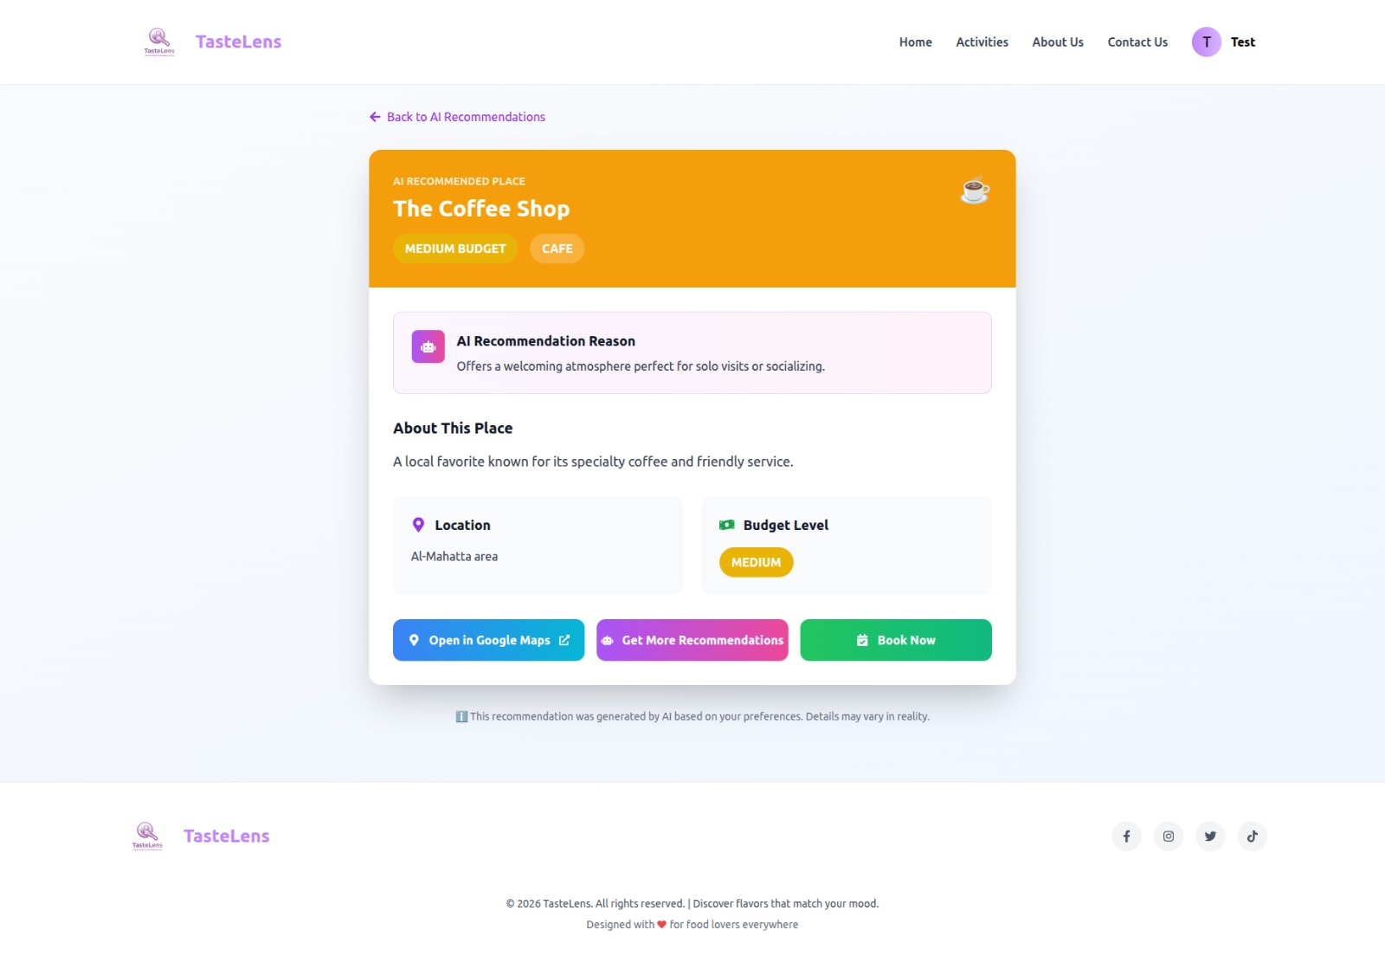
Figure A.8: Recommendation Details and Feedback Screen

6. Logging Out
Users can log out of the application at any time by selecting the Logout option from the menu. This ensures account security, especially when accessing the system from shared devices.

Conclusion
The Taste-Lens application is designed to be simple and intuitive, allowing users to easily navigate through its features. By following the steps outlined in this user manual, users can efficiently explore personalized food and entertainment recommendations tailored to their mood and preferences.

APPENDIX B : Project SOURCE CODE

The complete source code of the Taste-Lens project is fully implemented and provided as part of this submission. The source code includes all system components required for the operation of the application and reflects the final implemented version of the project.
The project source code consists of:
- Backend server code, responsible for business logic, authentication, database operations, and API communication.
- Frontend web application code, responsible for user interface design, user interaction, and communication with backend services.
- Database schema and migration files, supporting structured data storage and integrity.
- Configuration and supporting files required for system execution.
For clarity and maintainability, the source code is organized into separate modules and provided as compressed files. Including the full source code within the main body of the report is optional; therefore, it is attached separately and referenced in this appendix.

